

**BALDIVIS SECONDARY COLLEGE**

**APPLICATIONS - Unit 3 & 4**

**2020 Test 1 - Bivariate Data**

Student Name ______________________ Teacher Name ______________________

**Time allowed for this task:** 55 minutes, in-class, test conditions.

Section 1: 17 minutes + 2 minutes reading time

Section 2: 33 minutes + 3 minutes reading time

**Materials required:** Section 1 Resource free section (17 marks)

Standard writing equipment

SCSA Formula Sheet

Section 2 Calculator assumed section (33 marks)

Calculator (to be supplied by the student)

SCSA formula Sheet

One page A4 (single sided) hand written notes

**Other materials allowed:** Drawing templates

**Marks available:** **54 marks**

**Task Weighting: 7%**

**Section 1: Resource Free [17 marks]**

Question 1. [8 marks]

The scatterplot and least-squares line for a set of bivariate data (a, b) with correlation coefficient 0.85 is shown.

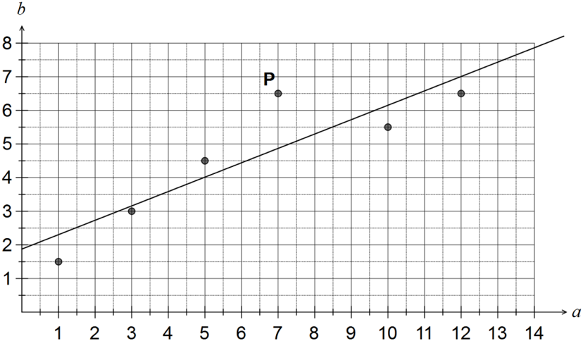

a) Describe the effect on the correlation coefficient if the point labelled P was removed from the dataset. (1 mark)

(b)   Describe the effect on the least-squares line if all data points with *a* < 4 were removed from the dataset. (2 marks)

(c)   Construct a residual plot for the six paired values on the axes below. (3 marks)

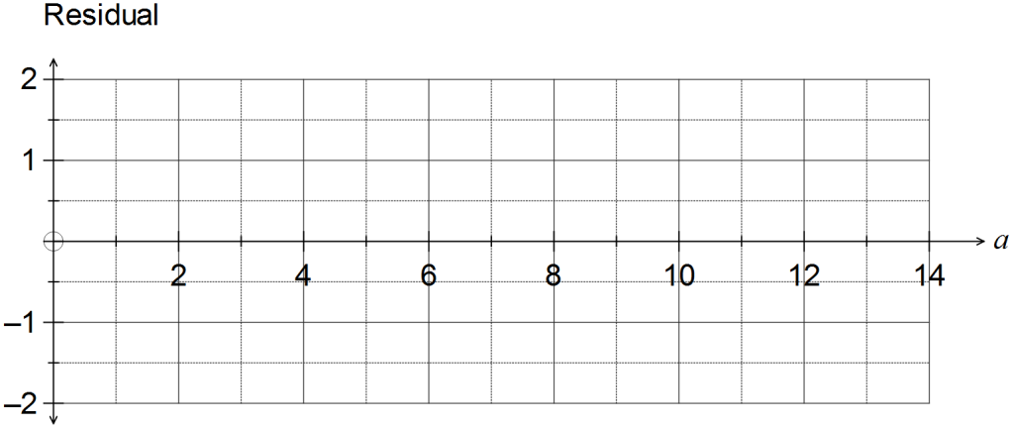

(d) Comment, with reasons, on the appropriateness of fitting a linear model to this dataset.  
 (2 marks)

**Question 2. [9 marks]**

A group of university students was asked the question ‘Does full attendance at school lead to an improved examination result?’

The results are summarised below.

a) Complete the two-way table below. (2 marks)

b) The incomplete table below shows row percentages. Complete the table. (2 marks)

c) Use the two-way table to draw a segmented column graph (3 marks)

d) Use the data to determine one association between the variables. Describe the association and explain your reasoning. (2 marks)

**Section 2: Calculator Assumed [33 marks]**

**Question 3. [9 marks]**

The table below shows the paired scores of twelve students in a Chemistry and a Physics exam, and the Chemistry score of a thirteenth student who was absent for the Physics exam.

a)   Name the explanatory variable. (1 mark)

b)   Calculate the correlation coefficient r*cp* (1 mark)

c) Graph the data on your calculator and use features of the graph to explain why the Physics teacher thought that it would be reasonable to predict the Physics score of Student 13 from their Chemistry score (2 marks)

(d)   Determine what percentage of the variation in the Physics scores can be explained by the variation in the Chemistry scores. (2 marks)

(e)   Determine the equation of the least-squares line that models the relationship between the Chemistry and Physics scores, rounding coefficients to two decimal places. (2 marks)

(f)   Predict the Physics score of Student 13. (1 mark)

Question 4 [12 marks]

The daily customer satisfaction index was measured by an online business over a period of ten consecutive days and the data collected is shown in the table below.

|  |  |  |  |  |  |  |  |  |  |  |
| --- | --- | --- | --- | --- | --- | --- | --- | --- | --- | --- |
| Day (d) | 1 | 2 | 3 | 4 | 5 | 6 | 7 | 8 | 9 | 10 |
| CS Index (s) | 92.1 | 91.2 | 90.6 | 88.9 | 88.1 | 87.7 | 87.4 | 86.6 | 85.4 | 85.1 |

a) Plot the above data on the axes below. (2)

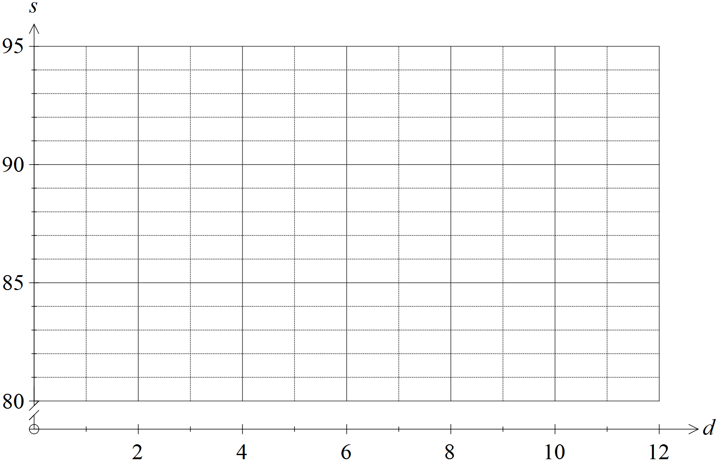

b) Determine the equation of the least-squares regression line that models the linear relationship between the explanatory and response variables. (2 marks)

c) Draw the least-squares line on the axes above. (2 marks)

d)Calculate and interpret Pearson’s correlation coefficient for the data. (1 mark)

e) Calculate and interpret the coefficient of determination for the data. (1 mark)

f)Is the regression line found in part b) an appropriate linear model? Justify your answer.

(2 marks)

g) Predict the customer satisfaction index for day 11. (1 mark)

h) Explain why a prediction for the customer satisfaction index for day 15 should be treated with caution. (1 mark)

**Question 5 [10 marks]**

The table below represents the results of a survey that determined the age of the survey participants and whether or not they were blood donors.

a) Complete the two-way table: (4 marks)

|  |  |  |  |
| --- | --- | --- | --- |
|  |  | | |
|  | Blood Donor | Non-donor |  |
| 16 – 18 years | 8 |  | 25 |
| 19 – 25 years | 17 | 42 |  |
| 26 – 40 years | 29 |  |  |
| 41 – 65 years |  | 33 | 42 |
|  |  | 143 |  |

b) How many 26–40 year olds were surveyed? (1 mark)

c) How many of the participants surveyed were blood donors? (1 mark)

d) Convert the two-way table to a percentage two-way table. (4 marks)

|  |  |  |  |
| --- | --- | --- | --- |
|  |  | | |
|  | Blood Donor | Non-donor |  |
| 16 – 18 years |  |  |  |
| 19 – 25 years |  |  |  |
| 26 – 40 years |  |  |  |
| 41 – 65 years |  |  |  |
|  |  |  |  |

**Question 6 [6 marks]**

Roe (eggs) collected from Salmon are considered a delicacy by some people.

Seven salmon, all with roe, are used to analyse the relationship between weight of a salmon, in kg,

and the weight of its roe, in grams. The resulting data are recorded in the table below.

|  |  |  |  |  |  |  |  |  |
| --- | --- | --- | --- | --- | --- | --- | --- | --- |
| X | Weight of Salmon (kg) | 1.2 | 1.6 | 1.7 | 1.8 | 1.9 | 2.1 | 2.2 |
| Y | Weight of Roe (g) | 42 | 45 | 46 | 50 | 53 | 56 | 54 |

a) Show the data on the axes below. (2 marks)

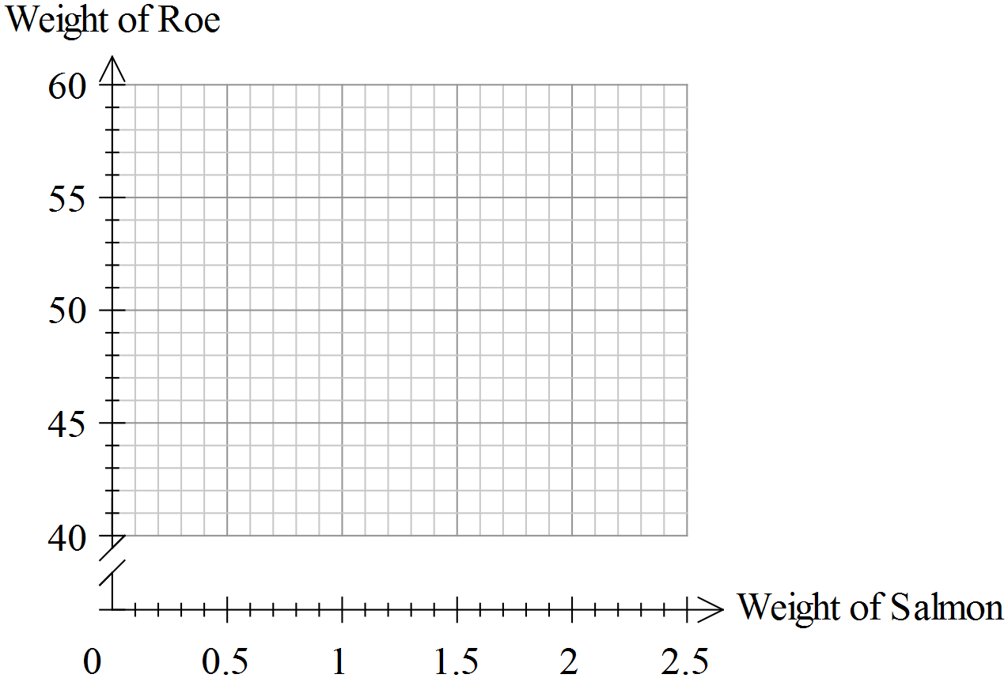

a) You are asked to predict the weight of roe from a salmon whose weight is 750g. Comment on this request. (2 marks)

b) What is the average rate of increase in the weight of roe for each kilogram

increase in the weight of the salmon? (1 mark)

c) The researcher concludes that it is the increase in weight of the salmon which causes the

increase in the weight of roe. Comment on this claim. (1 mark)